Odd Semester (2021)



**BINUS UNIVERSITY**

**BINUS INTERNATIONAL**

**Assignment Cover Letter**

**(Individual Work****)**

|  |  |  |  |  |  |  |  |  |
| --- | --- | --- | --- | --- | --- | --- | --- | --- |
|  | | | | |  | |  | |
| **Student Information**: **Surname** | | | | | **Given Names**  **Jason Christopher** | | **Student ID Number**  **2101725033** | |
| 1. | | **Chandra** |  | |
|  |  |
| **Course Code** | **: COMP6502** |  |  | | **Course Name** | | **: Introduction to Programming** | |
| **Class** | **: L1BC-BLK** |  |  | | **Name of Lecturer(s)** | | **:** 1.Minaldi Loeis | |
|  |  |  |  | |  | | 2.Jude Martinez | |
| **Major** | **: CS** |  |  | |  | |  | |
| **Title of Assignment**  (if any) | : Wild West Quick Draw | |  |  | |  | |  | |
| **Type of Assignment**    **Submission Pattern** | **: Final Project** |  |  | |  | |  | |
| **Due Date** | **: 6-11-2017** |  |  | | **Submission Date** | | **: 6-11-2017** | |

The assignment should meet the below requirements.

1. Assignment (hard copy) is required to be submitted on clean paper, and (soft copy) as per lecturer’s instructions.
2. Soft copy assignment also requires the signed (hardcopy) submission of this form, which automatically validates the softcopy submission.
3. The above information is complete and legible.
4. Compiled pages are firmly stapled.
5. Assignment has been copied (soft copy and hard copy) for each student ahead of the submission.

# Plagiarism/Cheating

Binus International seriously regards all forms of plagiarism, cheating and collusion as academic offenses which may result in severe penalties, including loss/drop of marks, course/class discontinuity and other possible penalties executed by the university. Please refer to the related course syllabus for further information.

# Declaration of Originality

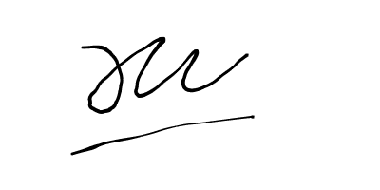By signing this assignment, I understand, accept and consent to Binus International terms and policy on plagiarism. Herewith I declare that the work contained in this assignment is my own work and has not been submitted for the use of assessment in another course or class, except where this has been notified and accepted in advance.

Signature of Student: (Name of Student)

1. Jason Christopher Chandra

**“Wild West Quick Draw”**

**Name : Jason Christopher Chandra**

**ID : 2101725033**

1. **Description**

**The function of this program:**

This program is meant to be a fun and very simple 2-player game set in the Wild West! This game can be played by people of all ages.

**II. a. Design/Plan**

**Project’s Hierarchy Chart**

Player 1 Wins

Player 2 Wins

Run Game

sys.exit()

Start

Game

Exit

Game

Intro

Screen

sys.exit()

Player 1&2

Input

**II. B. Explanation of Each Function and Classes**

**message_display: (main.py*)***

* Holds the font settings, text’s position settings and can screen.rect the text using font settings.

**text_objects: (main.py)**

* Used to initialize pygame.font, render text using pygame.font and to rect the text.

**button & button2: (main.py)**

* Contains button settings, such as making the button clickable, the button’s colour,position,and text on button

**Intro: (main.py)**

* Contains the functions to create an intro screen with buttons and a background image. The buttons also have colors and functionality where the green button will start the game and the red button will exit the game.

**run_game: (main.py)**

* It contains the functions needed to run the game. It is the core / primary code of this program.

**Protagonist: (protagonist.py)**

* This is the protagonist class. It contains all the settings for Player 1’s Character such as Player 1’s character image, Player 1’s character’s position, screen.blit,etc..

**Antagonist: (antagonist.py)**

* This is the antagonist class. It is similar to the Protagonist class, and contains all the settings for Player 2’s character such as character image, position,.rect, screen.blit,etc…

**Settings: (settings.py)**

* This is the settings class. It contains the general settings for the intro screen and the game. Most numeric information is kept in here along with screen size, background images, font sizes, text positions, etc...

**UML Diagram:**

|  |
| --- |
| Settings |
| +Screen_Width = 640  +Screen_Height = 480  +Title_Height = 75  +Bg_Color = (0,230,0)  +Bg_Image = pygame.image.load(**"22.png"**)  +Intro_Image = pygame.image.load(**"introscreen.jpg"**)  +Font_Size = 115  +Small_Font = 16  +Exit_Font = 22  +Title_Font =65  +ButtonX = 150  +Button2X = 390  +ButtonY = 350  +Button_Width =120  +Button_Height = 50  +Fonty = 35  +CharaY = 381  +Play1X = 210  +Play2X = 420  +RectY = 132  +RectX1 = 81  +RectX2 = 526 |

|  |
| --- |
| Protagonist |
| +Screen  +Image = pygame.image.load(**"aimright.png"**)  + Image.get.rect()  +Screen.get.rect()  +Center = Pos |
| +blitme() |

|  |
| --- |
| Antagonist |
| **+**Screen  +Image = pygame.image.load(**"aimleft.png"**)  +Image.get.rect()  +Screen.get.rect()  +Center = Pos |
| +blitme() |

**III. How it works:**

First, when you run the program, it will run the intro function and run the intro screen where there are 2 buttons in front of the background image. The first button, “You Ready?”, will run the game, and the second button, “Too Scared ?” will run sys.exit ().

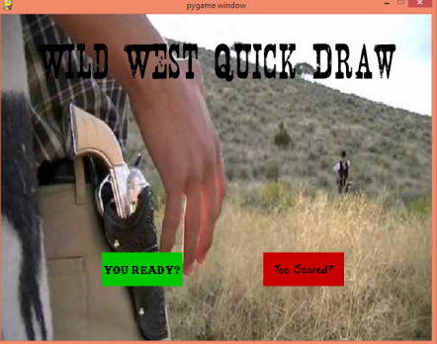

**N**ext, when you run the game, There will be some music playing in the background and 2 character models in front of a wild west theme background on the screen, and after that 3 words will pop up at different times, “Ready…”,”Steady…”,”Fire!!!”

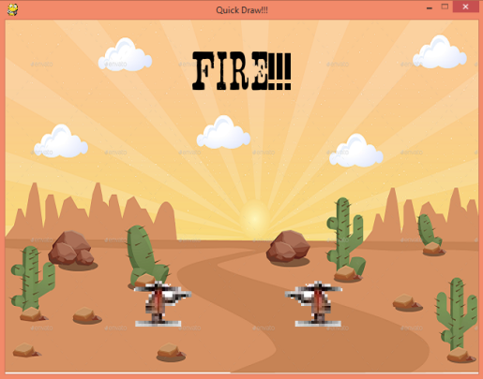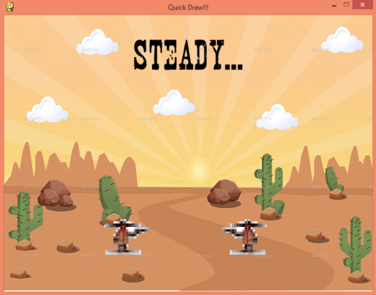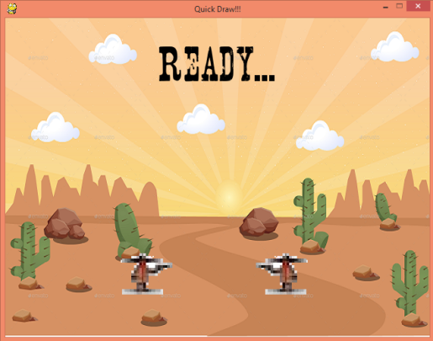

Then, after that another text will pop up, and that text is the instruction for both players which is to press “S” in the keyboard for player 1 and press “L” for player 2.After both players inputted their respective instructions, the winner of the game will be determined. The winner of this game is determined by who press their respective instructions first.

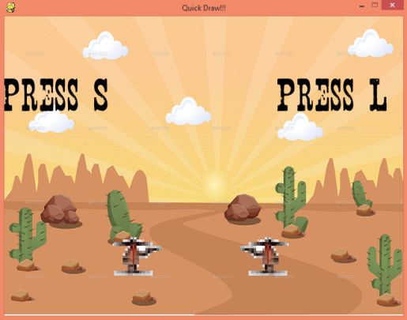

After the winner is determined, some text will pop up on screen, either saying “Player 1 Wins” or “Player 2 Wins”.

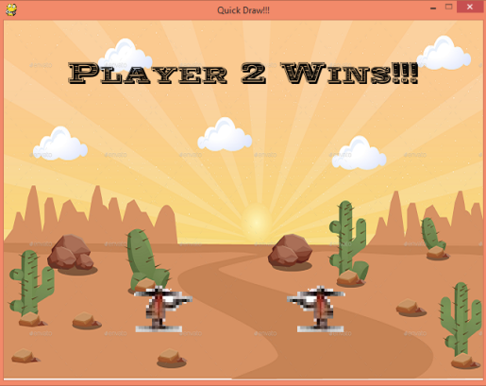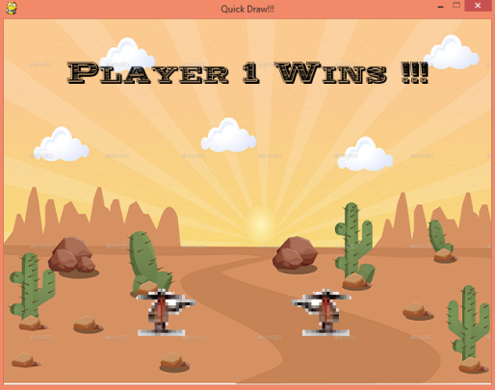

**Or**

**IIII. Source Code**

1. ***Main.py***

**import** pygame*#import pygame***import** sys *#import sys***import** time *#import time***from** settings **import** Settings *#import settings class***from** protagonist **import** Protagonist *#import protagonist class***from** antagonist **import** Antagonist *#import antagonist class***from** pygame.locals **import** *  
  
**def** message_display(text,screen):  
 ai_settings = Settings()*#make a variable to use the settings class* largeText = pygame.font.Font(**'freesansbold.ttf'**,ai_settings.font_size)*#font settings* TextSurf, TextRect = text_objects(text, largeText)*#to screen.rect the text using the font settings* TextRect.center = ((ai_settings.screen_width/2),(ai_settings.screen_height/2))*#the text's position settings* screen.blit(TextSurf, TextRect)*#to blit the text onto the screen* pygame.display.update()*#update the screen so the text appears on screen* time.sleep(2)*# pauses program for 2 seconds***def** text_objects(text,font):  
 pygame.font.init()*#initialize pygame.font* textSurface = font.render(text, **True**,(0,0,0))*#to render the text using pygame.font* **return** textSurface,textSurface.get_rect()*# to rect the text***def** button(msg,x,y,w,h,ic,ac,screen):*#button 1 settings* ai_settings = Settings()  
 mouse = pygame.mouse.get_pos()*#to get mouse's position* click = pygame.mouse.get_pressed()*#so the button becomes clickable* **if** x+w > mouse[0] > x **and** y+h > mouse[1] > y:*# to add functionality to the button* pygame.draw.rect(screen,ic,(x,y,w,h))  
 **if** click[0] == 1:  
 run_game()  
 **else**:  
 pygame.draw.rect(screen,ac,(x,y,w,h))*#to change button color when user's mouse hovers it* smallText = pygame.font.Font(**"play.otf"**,ai_settings.small_font)*#font settinga* textSurf, textRect = text_objects(msg, smallText)*#to screen.rect the message using the font settings* textRect.center = ( (x+(w/2)), (y+(h/2)) )*#to set the text's position* screen.blit(textSurf, textRect)*#to blit the text***def** button2(msg,x,y,w,h,ic,ac,screen):*#button 2 settings* ai_settings = Settings()  
 mouse = pygame.mouse.get_pos()*#to get mouse's position* click = pygame.mouse.get_pressed()*#so we can click the buttons* **if** x+w > mouse[0] > x **and** y+h > mouse[1] > y:*#to add function to button (in this case exit)* pygame.draw.rect(screen,ic,(x,y,w,h))  
 **if** click[0] == 1:  
 sys.exit()  
  
 **else**:  
 pygame.draw.rect(screen,ac,(x,y,w,h))*#to change button color when the user's mouse hovers it* smallText = pygame.font.Font(**"exit.ttf"**,ai_settings.exit_font)*#font settings for text* textSurf, textRect = text_objects(msg, smallText)*#to screen.rect the text using the Font settings* textRect.center = ( (x+(w/2)), (y+(h/2)) )*#the text's position* screen.blit(textSurf, textRect)*#to blit the text***def** Intro():  
 pygame.init()*#to initialize pygame* pygame.font.init()*#to initialize pygame.font for font settings* intro = **True** *#to create an intro function* **while** intro:  
 **for** event **in** pygame.event.get():*#to quit the intro screen* **if** event.type == pygame.QUIT:  
 sys.exit()  
 ai_settings = Settings()*#to use settings from the Settings class in the Intro Screen.* screen = pygame.display.set_mode((ai_settings.screen_width,ai_settings.screen_height))*#intro screen's screen setting* Text = pygame.font.Font(**'NASHVILL.TTF'**,ai_settings.title_font)*#font settings for Wild West Quick draw* TextSurf, TextRect = text_objects(**"Wild West Quick Draw"**,Text)*#the text and the font settings* TextRect.center = ((ai_settings.screen_width/2),ai_settings.title_height)*# to set Quick Draw Wild West position* screen.blit(ai_settings.intro_image,ai_settings.intro_image.get_rect())*#to make intro's bg image* screen.blit(TextSurf,TextRect)*# to blit Wild West Quick Draw* button(**"You Ready?"**,ai_settings.buttonx,ai_settings.buttony,ai_settings.button_width,ai_settings.button_height,(0,230,0),(0,200,0),screen)*#to make start button in intro screen* button2(**"Too Scared?"**,ai_settings.button2x,ai_settings.buttony,ai_settings.button_width,ai_settings.button_height,(255,0,0),(200,0,0),screen=screen)*#to make exit button in intro screen* pygame.display.update()*#to update the screen***def** run_game():  
 pygame.init()*#initialize pygame* pygame.mixer.init() *#initialize pygame.mixer for music* pygame.mixer.music.load(**"Western.mp3"**)*#to load bg music* pygame.mixer.music.play()*#to play bg music* ai_settings = Settings()*#to use settings from the Settings class in run_game* screen = pygame.display.set_mode((ai_settings.screen_width,ai_settings.screen_height))*#screen size* pygame.display.set_caption(**"Quick Draw!!!"**)*#For Caption* protagonist = Protagonist(screen,[ai_settings.Play1X,ai_settings.charay])*#to create antagonist using the Protagonist Class* antagonist = Antagonist(screen,[ai_settings.Play2X,ai_settings.charay])*#to create antagonist using the Antagonist class* currentsec1 = time.localtime()[-4]*#for timer* winner = **None** *#to create winner variable.* **While True**:  
 currentsec2 = time.localtime () [-4] *#for timer* **for** event **in** pygame.event.get ():*#so we can quit the game* **if** event.type == pygame.QUIT:  
 sys.exit ()  
 **if** currentsec2 == (currentsec1 + 6):  
 **if** event.type == KEYDOWN: *#to decide the winner and load the bullet sound.* **if** event.key == K_s **and** winner == **None**:  
 pygame.mixer.music.load(**"bullet.mp3"**)  
 pygame.mixer.music.play()  
  
 time.sleep(2)  
  
 winner = **"player1"  
  
 if** event.key == K_l **and** winner == **None**:  
 pygame.mixer.music.load(**"bullet.mp3"**)  
 pygame.mixer.music.play()  
  
 time.sleep(2)  
  
 winner = **"player2"** screen.blit(ai_settings.bg_image,ai_settings.bg_image.get_rect())*#to blit the bg_image* protagonist.blitme()*#to blit player 1* antagonist.blitme()*#to blit player 2* currentsec2 = time.localtime()[-4]  
 **if** currentsec2 == (currentsec1 + 2):*# to blit Ready...* Text = pygame.font.Font(**'NASHVILL.TTF'**,ai_settings.title_font)  
 TextSurf, TextRect = text_objects(**"Ready..."**,Text)  
 TextRect.center = ((ai_settings.screen_width/2),ai_settings.title_height)  
  
 screen.blit(TextSurf,TextRect)  
  
 **if** currentsec2 == (currentsec1 + 4):*#to blit Steady...* Text = pygame.font.Font(**'NASHVILL.TTF'**,ai_settings.title_font)  
 TextSurf, TextRect = text_objects(**"Steady..."**,Text)  
 TextRect.center = ((ai_settings.screen_width/2),ai_settings.title_height)  
  
 screen.blit(TextSurf,TextRect)  
  
 **if** currentsec2 == (currentsec1 + 5):*#to blit FIRE!!!* Text = pygame.font.Font (**'NASHVILL.TTF'**, ai_settings.title_font)  
 TextSurf, TextRect = text_objects (**"Fire!!!"**, Text)  
 TextRect.center = ((ai_settings.screen_width/2), ai_settings.title_height)  
  
 screen.blit (TextSurf,TextRect)  
  
 **if** currentsec2 == (currentsec1 + 6):*#to blit Player 1's Instruction in the screen.* Text = pygame.font.Font (**'NASHVILL.TTF'**, ai_settings.title_font)  
 TextSurf, TextRect = text_objects (**"Press S”,** Text)  
 TextRect.center = (ai_settings.rectx1, ai_settings.recty)  
  
 screen.blit (TextSurf, TextRect)  
  
 **if** currentsec2 == (currentsec1 + 6):*#to blit Player 2's Instruction to the screen.* Text = pygame.font.Font (**'NASHVILL.TTF'**, ai_settings.title_font)  
 TextSurf, TextRect = text_objects (**"Press L"**, Text)  
 TextRect.center = (ai_settings.rectx2, ai_settings.recty)  
  
 screen.blit (TextSurf, TextRect)  
  
 **if** winner == **"player1"**:*#to blit "Player 1 Wins!!!" in the screen.* Text = pygame.font.Font(**'WOODCUT.TTF'**,ai_settings.fonty)  
 TextSurf, TextRect = text_objects(**"Player 1 Wins !!!"**,Text)  
 TextRect.center = ((ai_settings.screen_width/2),ai_settings.title_height)  
  
 screen.blit(TextSurf,TextRect)  
  
 **if** currentsec2 == (currentsec1 + 10):  
 time.sleep(3)  
 Intro()  
  
 **if** winner == **"player2"**:*#to blit "Player 2 Wins!!!" in the screen.* Text = pygame.font.Font(**'WOODCUT.TTF'**,ai_settings.fonty)  
 TextSurf, TextRect = text_objects(**"Player 2 Wins!!!"**,Text)  
 TextRect.center = ((ai_settings.screen_width/2),ai_settings.title_height)  
  
 screen.blit(TextSurf,TextRect)  
  
 **if** currentsec2 == (currentsec1 + 10):*#to re run the intro screen* time.sleep(3)  
 Intro()  
  
 pygame.display.update()*#update the screen*Intro()*#calling the intro screen*run_game()*#to run the game*

1. ***settings.py***

**import** pygame *#to initialize pygame***class** Settings():*#to make settings class* **def** __init__(self):*#initialize the class* self.screen_width = 640*#set the screen width* self.screen_height = 480*#set the screen height* self.title_height = 75  
 self.bg_color = (0,230,0)*#set the bg_color* self.bg_image = pygame.image.load(**"22.png"**)*#load the game's background image* self.intro_image = pygame.image.load(**"introscreen.jpg"**)*#to load the intro screen's background image* self.font_size = 115  
 self.small_font = 16  
 self.exit_font = 22  
 self.title_font = 65  
 self.buttonx = 150  
 self.button2x = 390  
 self.buttony = 350  
 self.button_width = 120  
 self.button_height = 50  
 self.fonty = 35  
 self.charay = 381  
 self.Play1X= 210  
 self.Play2X = 420  
 self.recty = 132  
 self.rectx1 = 81  
 self.rectx2 = 526

1. ***protagonist.py***

**import** pygame*#to initialize pygame***class** Protagonist():*#to make protagonist class(Player 1 )* **def** __init__(self,screen,pos):  
 self.screen = screen *#so player 1 's character will load on the screen* self.image = pygame.image.load(**"aimright.png"**)*#to load player 1's character image* self.rect = self.image.get_rect()*#to rect player 1's character* self.screen_rect = screen.get.rect()*#to rect the screen* self.rect.centerx,self.rect.centery = pos *#to set player1's position* **def** blitme(self):*#to blit player 1 onto the screen* self.screen.blit(self.image, self.rect)

1. ***antagonist.py***

**import** pygame*#to initialize pygame***class** Antagonist():*#to create the antagonist class (player 2)* **def** __init__(self,screen,pos):  
 self.screen = screen *#to load player 2's character onto the screen* self.image = pygame.image.load(**"aimleft.png"**)*#to load player 2's character* self.rect = self.image.get_rect()*#to rect player 2's character* self.screen_rect = screen.get_rect()*#to rect the screen* self.rect.centerx,self.rect.centery = pos *#to set player 2's character's position* **def** blitme(self):*#to blit player 2's character* self.screen.blit(self.image, self.rect)

Sources:

1. Python Crash Course
2. stackoverflow.com
3. Python Docs
4. Georgius Kurli
5. Ivan Ezechial Suratno
6. Jason Erniody
7. Python-programming.net